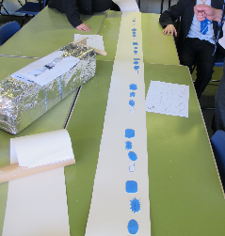
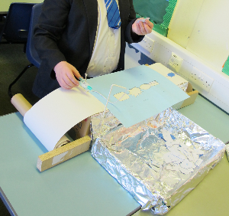
Making a French Sentence Machine (a world first).

You have:
One long thin box, two kitchen roll holders, one cardboard lid, two cut-down wallpaper rolls (one loaded, one empty), the template, the French shapes, a handle, some blutac, some tinfoil, a straw, a clothes peg, some tape and some string. And some sticky labels.

1. The two kitchen roll holders need taping strongly to the TOP of the big box as in the diagram. Carefully cover the box and the base of the kitchen roll holders in tinfoil.

2. The wallpaper rolls then fit on the kitchen roll holders. The loaded roll on the right.

3. Fit the handle to the left hand empty roll. Start to unroll the paper, take it across the long box and stick the end to the empty roll. Use the handle to wind some on.

Paper sits on top of long box
Full roll goes on right hand end

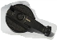
handle

4. Cut out the holes in the template and fix it in place on one side as shown in the diagram, paying attention to the instructions on the template. They will tell you which way round it goes.

Tape template to box on this side only
Holes go over the paper

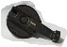

5. Cut out all the French in the correct shapes and stick blutac to the back of each. Place the shapes in the tray. Attach the tray to the machine and add labels to explain what the machine does.

6. Thread about 33 cm of string through the straw. Fix the bottom end of the string to the back of the machine. Fix the straw to the machine, allowing some slack in the string. Fix the peg to the other end of the string to make the picker.
String goes through straw and attached to box.

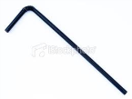
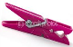
Tray

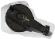
Peg attached to string

Straw attached to box

7. Use the machine to start your sentence. Use the picker to grab shapes and insert into the template. Use the blutac to fix to the paper. When you have inserted 4 shapes in the correct holes, wind the paper to the left and continue.

